Take a tour

# Project workflow

## Quality control lifecycle process

Prerequisites / input criteria

Analysis documentation is finished and reviewed including the user stories

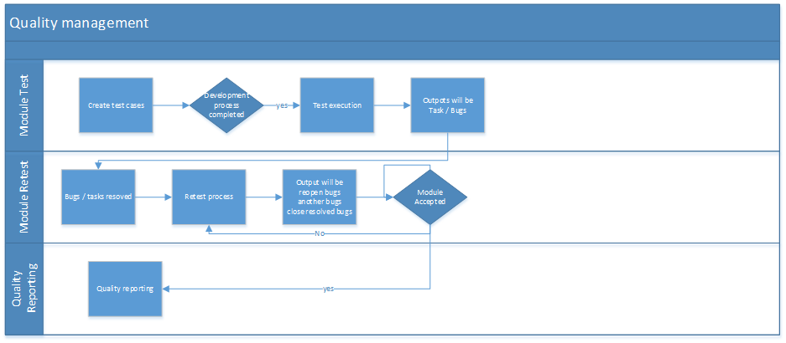

## Change request Management

Prerequisites /input criteria

Project modules are already accepted by the customer and the new requirements are not bugs

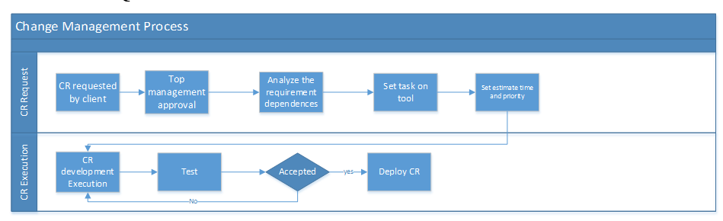

# Quality Check lists

* + UX checklist
    - [ux checklistV1 (1).xlsx](https://thetrans4mers-my.sharepoint.com/:x:/g/personal/it_roqay_com_kw/EXCferXTSr5LhlO_6WCukGEBH555lkElrEvEBIh7E1s8TA?e=J0yvoS)
  + Security checklist
    - [Web Application Security Testing Checklist.xlsx](https://thetrans4mers-my.sharepoint.com/:x:/g/personal/it_roqay_com_kw/ERAL-1scg2lFlqJIwgHZjsMBAOJRF8XzBZVrKHpU-gHD3Q?e=peIve0)
  + User stories check list
    - [user stories check list (1).xlsx](https://thetrans4mers-my.sharepoint.com/:x:/g/personal/it_roqay_com_kw/ERmeq69qCCVEkGXSuIJOFcUBof-kux7o-MC5SqG51K2SRA?e=kXjPvc)
  + Mobile testing check list
    - [MobileChecklist.xlsx](https://thetrans4mers-my.sharepoint.com/:x:/g/personal/it_roqay_com_kw/EUrEm9wYk_hOnf9h1Ka0824BrZBRVxXkJrKLe2PjTyDAvQ?e=Dc9Vyi)

# How to manage your working project

## Severity vs priority

[Severity](https://glossary.istqb.org/en/search/severity) is “the degree of impact that a defect has on the development or operation of a component or system.”

[Priority](https://glossary.istqb.org/en/search/priority) is “the level of (business) importance assigned to an item, e.g., defect.

According to this perspective you decide what should be done first

## Focus in current deliverables time line items

Project monitor plan should be shared with each team member in order to achieve a self-organized team

## Be a team player

Every time a team member receives a task, he should change the task status (according to his location in team) until it’s done and pass it on to the next team member with updated status

# Test cases and bug templates

## Test case pillars

1. Test case title
2. Test case steps
3. Expected results

## Bug pillars

1. Bug Title
2. Link or related screen
3. Username and password
4. Steps
5. Actual result
6. Expected result
7. Screen shots and videos to catch the issue